You have 'Vacation booking' application . Need to do QA

1. gather clarification questions
2. what and how you will test

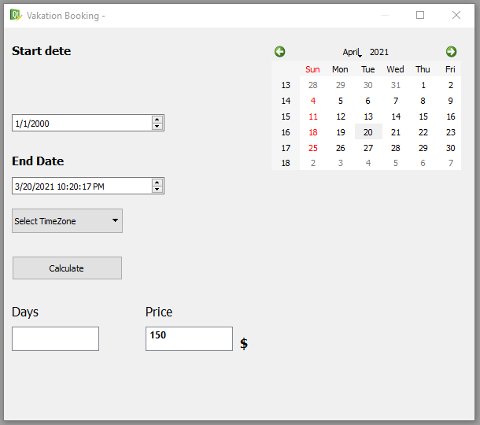

1. **Gather clarification questions**

* Before Sunday column there is a nameless column for weeks, perhaps we need to clarify it.

* Clarify the necessity of “Select TimeZone” button. (It is a bug )

* Clarify the left and right arrows functionality. Does it change only month? How we could change the year easily?

*Does the amount of vacation payment just for 1 day on “Price” field.

There are more clarification questions

1. **What and how you will test**

Non-functional testing

* Spelling mistake on app name: Vacation booking

* Meaningless hyphen after app name

* Spelling mistake on Start date

* Start date and End Dates are written on different ways (uppercase, lowercase)

*After April there is a symbol, which necessity isn’t understandable (It is a bug )

* The position of Start date is far away from appropriate field (It is a bug )

Functional testing

* At first check all input fields: Days and Price, whether they inputable or not.

*Check the connection of calendar with Start Date & End Date drop up-down fields:

If I choose a day on Start Date or in End Date, is the day is fixed and visible on calendar.

And the opposite side of connection: after choosing the date on calendar, on which field (Start or End Date) it is fixed.

* Check the calculate button functionality by using Start date & End Date. Whether Days & Price correctly calculated.

*I would check if after changing Start Date or End Date the Days & Price are changed or only after clicking on calculate button they changed.

*Check if Start Date or End Date are empty, and we click on calculate, is it possible to see any result in Days field, and in Price field.

*After deleting Price field (Start Date and End Dates are chosen), click on calculate and check with which Price it is calculated per day

*Check calculate functionality if Price isn’t filled and other fields filled in correct way

*Check if without choosing days, we can input some integer number on Days field and calculate Price.

**Good cases ☺**